Bahria University,

Karachi Campus



COURSE: CSL 220, DATABASE MANAGEMENT   
SYSTEMS

TERM: SPRING 2022, CLASS: BSE- 4(B)

Submitted By:

**M Muaz Shahzad 02-131202-081**

(Name) (Reg. No.)

Submitted To:

**Engr. Laraib Siddiqui/Engr. Ayesha Khan**

Signed Remarks: Score:

INDEX

|  |  |  |  |  |
| --- | --- | --- | --- | --- |
| SNO | DATE | LAB NO | LAB OBJECTIVE | SIGN |
| 1 | 8-3-22 | 1 | **Intro To DBMS** |  |
| 2 | 15-3-22 | 2 | **Aggregate Functions** |  |
|  |  |  |  |  |
|  |  |  |  |  |
|  |  |  |  |  |
|  |  |  |  |  |
|  |  |  |  |  |
|  |  |  |  |  |
|  |  |  |  |  |
|  |  |  |  |  |
|  |  |  |  |  |

Bahria University,

Karachi Campus



LAB EXPERIMENT NO.

**1**

LIST OF TASKS

|  |  |
| --- | --- |
| TASK NO | OBJECTIVE |
| **1** | Get Order id, Product id, Unit price from Order Details. |
| **2** | Find Title of employee Nancy. |
| **3** | Display data of all employees those working as Sales Representative from London |
| **4** | Display product name whose unit price are greater than 90$ |
| **5** | Write a query to get current Product list (Product ID and name). |
| **6** | Fetch data of customers where country is "Germany" AND city must be "Berlin" OR "München" (use parenthesis to form complex expressions) |
| **7** | Fetch data of customers from all countries except Germany and USA |
| 8 | Fetch Discontinued products who’s price is greater than 20 |
|  |  |

Submitted On:

**22/3/2022**

(Date: DD/MM/YY)

**Task No. 1: Get Order id, Product id, Unit price from Order Details.**

**SOLUTION:** select orderid,productid,unitprice from dbo.[order details]

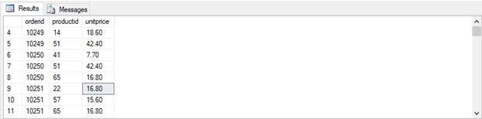**OUTPUT:**

**Task No. 2: Find Title of employee Nancy.**

**SOLUTION:** select title from employees where firstname='nancy'

**OUTPUT:**

**TASK NO. 3: Display data of all employees those working as Sales Representative from London**

**SOLUTION:** select * from employees where city='london' and title='sales representative'

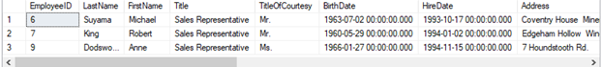**OUTPUT:**

**TASK NO. 4: Display product name whose unit price are greater than 90$**

**SOLUTION:** select productname from products where unitprice>90

**OUTPUT:**

**TASK NO. 5:** **Write a query to get current Product list (Product ID and name).**

**SOLUTION:** select productid,productname from products

**OUTPUT:**

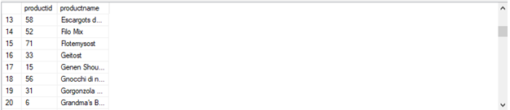

**TASK NO. 6: Fetch data of customers where country is "Germany" AND city must be "Berlin" OR "München" (use parenthesis to form complex expressions)**

**SOLUTION:** select * from customers where country='germany' and (city='berlin') OR (city='munchen')

**OUTPUT:**



**TASK NO. 7: Fetch data of customers from all countries except Germany and USA**

**SOLUTION:** select * from customers where (country<>'germany') or (country<>'usa')

**OUTPUT:**

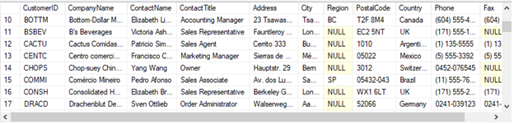

**TASK NO. 8: Fetch discontinued products whose price is greater than 20**

**SOLUTION:**

select discontinued from products where unitprice>20

**OUTPUT:**

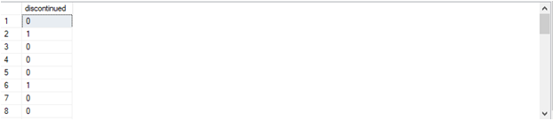

Bahria University,

Karachi Campus

LAB EXPERIMENT NO.

**2**

LIST OF TASKS

|  |  |
| --- | --- |
| TASK NO | OBJECTIVE |
| **1** | Get the price of an order (by multiplying unit price by quantity). |
| **2** | Display all cities that employees belong to but don’t allow repetition. |
| **3** | Find complete name of all employees. |
| **4** | Display all the orders where unit price lies in the range of 10$ to 40$. |
| **5** | Display the company name where Region is NULL in Customer Table. |
| **6** | List all products where Unit Price is not in 10,12,15,17 or 19 |
| **7** | Display the highest, lowest, sum and average Unit Price of each Category, where highest Unit Price lies in the range of 50$ to 100$. Label column as Category ID, Maximum, Minimum, Sum and Average, respectively. (Table: Products) |
| **8** | From customers table, Count all customers is each region where region is not null. (Table: Customers) |
| **9** | Write a query to display the number of Contact Name with same Contact Title. Sort contact title in descending order. (Table: Customers) |
| **10** | Write a query that count all orders against each product id. No of orders should be greater than 50. (Table: [Order Details]) |
| 11 | List only those cities in which more than or equals to 2 employees are living |

Submitted On:

**22/3/2022**

**TASK NO. 1: Get the price of an order (by multiplying unit price by quantity).**

**SOLUTION:** select unitprice*quantity as Price,orderid from [order Details]

**OUTPUT:**

**TASK NO.2: Display all cities that employees belong to but don’t allow repetition.**

**SOLUTION:** select distinct city from employees

**OUTPUT:**

**TASK NO. 3: Find complete name of all employees.**

**

**TASK NO. 4: Display all the orders where unit price lies in the range of 10$ to 40$.**

**SOLUTION:** select * from [order Details] where unitprice between 10 and 40

**OUTPUT:**

**TASK NO. 5: Display the company name where Region is NULL in Customer Table.**

**SOLUTION:** select CompanyName from customers where region is null

**OUTPUT:**

**TASK NO. 6: List all products where Unit Price is not in 10,12,15,17 or 19**

**SOLUTION:** select * from products where unitprice NOT IN ('10','12','15','17','19')

**OUTPUT:**

**TASK NO. 7: Display the highest, lowest, sum and average Unit Price of each Category, where highest Unit Price lies in the range of 50$ to 100$. Label column as Category Id, Maximum, Minimum, Sum and Average, respectively. (Table: Products)**

**SOLUTION:** select Max(unitprice)as [Highest unitprice],Min(unitprice)as [lowest unitprice],sum(unitprice)as [sum unitprice],Avg(unitprice)as [average unitprice] from products group by (categoryId) having Max(unitprice) Between 50 and 100

**OUTPUT:**

**TASK NO. 8:** **From customers table, Count all customers is each region where region is not null. (Table: Customers)**

**SOLUTION:** SELECT COUNT(CustomerID) as Numofcustomers ,region FROM Customers GROUP BY Region having region is not null

**OUTPUT:**

**TASK NO. 9:** **Write a query to display the number of contact Name with same Contact Title. Sort contact title in descending order. (Table: Customers)**

**SOLUTION:** SELECT distinct(ContactTitle), COUNT(ContactName) as[ Name of contact] FROM Customers GROUP BY contactTitle ORDER BY (contactTitle) DESC

**OUTPUT:**

**TASK NO. 10: Write a query that count all orders against each product id. No of orders should be greater than 50. (Table: [Order Details])**

**SOLUTION:** SELECT productid ,COUNT(orderid) as 'ID Order' FROM [order details] GROUP BY productid having COUNT(orderid)>50

**TASK NO. 11: List only those cities in which more than or equals to 2 employees are living**

**SOLUTION:** SELECT city ,COUNT(Employeeid) as 'Employees ID' FROM Employees GROUP BY city having COUNT(employeeid)>=2

